NORTH SOUTH UNIVERSITY
Department of Computer Science and Engineering
CSE 499A: Senior Design Capstone Project Report
CardioRisk AI:
A Multimodal Deep Learning System for Smartphone-Based Cardiovascular Risk Assessment
Submitted by:
Hussain Mahabub (Student ID: 2111015642)
CSE 499A – Section 10 – Group 10
Faculty Supervisor:
Shahnewaz Siddique
Department of Computer Science & Engineering
Date of Submission: September 08, 2026

Table of Contents
1. Executive Summary & Abstract ............................................................................................ 3
2. Section I: Introduction and Problem Statement (What?) ..................................................... 4
2.1 Global Cardiovascular Burden & Diagnostic Deficits .................................................... 4
2.2 Project Scope & Objectives ........................................................................................... 4
3. Section II: Background and Literature Review (Why?) ........................................................ 5
3.1 Computational Cardiology Benchmarks ........................................................................ 5
3.2 Identified Research Gaps .............................................................................................. 6
3.3 Engineering Motivation & Clinical Justification ............................................................. 6
4. Section III: Proposed Model, Solution, and Design (How?) ................................................ 7
4.1 Four-Tier Software Engineering Architecture (CSE 327) ............................................... 7
4.2 Digital Signal Processing (DSP) Pipelines ..................................................................... 8
4.3 Deep Convolutional & Tree-Based Machine Learning Models ....................................... 9
4.4 Dynamic Confidence-Weighted Ensemble Fusion Engine ........................................... 10
4.5 Explainable AI (XAI) with SHAP and Counterfactuals ................................................. 11
5. Section IV: Preliminary Implementation Results (499A) .................................................... 12
5.1 Model Calibration and Benchmark Accuracies ............................................................ 12
5.2 Detailed Empirical Performance Breakdown ............................................................. 13
5.3 Sensor Fault Tolerance and Error Handling ................................................................ 14
6. Section V: Future Work & Roadmap for CSE 499B ........................................................... 15
6.1 Dedicated IoT Hardware Module (~$95 BOM) .............................................................. 15
6.2 Firmware Concurrency & Time-Series Synchronization ............................................... 16
6.3 Neural Stacking Meta-Learner & Clinical Matched Validation ..................................... 16
7. Section VI: References (IEEE Format) ................................................................................. 17

1. Executive Summary & Abstract
Cardiovascular diseases (CVDs) represent the leading cause of premature mortality worldwide. Conventional risk identification relies on static demographic scoring systems or costly hospital-grade diagnostics. This capstone report presents CardioRisk AI, a multimodal deep learning software platform engineered to perform non-invasive 10-year cardiovascular risk assessment using commodity mobile hardware and physiological data streams. The system incorporates six physiological modalities: clinical tabular variables, 12-lead electrocardiography (ECG), phonocardiography (heart sounds), photoplethysmography (PPG/HRV), seismocardiography (SCG), and retinal fundus imaging. Empirical benchmarks recovered directly from disk training logs demonstrate individual model accuracies of 81.00% (AUC 0.9360) on ECG and 75.31% (AUC 0.8000) on heart sounds, with calibrated Gradient Boosting achieving 72.67% (AUC 0.7940) on clinical records. To resolve the performance dilution inherent in static ensemble averaging (which dropped accuracy to 76.79%), we deploy a Dynamic Confidence-Weighted Ensemble Fusion algorithm that adaptively redistributes modality weights in real time based on prediction certainty. When combining synchronized high-fidelity acoustic and electrophysiological signals, the dual ensemble achieves 86.00% accuracy (AUC 0.9420). The system incorporates Explainable AI (SHAP) and algorithmic counterfactual lifestyle recommendations, establishing a robust software precursor for physical IoT hardware prototyping in CSE 499B.

2. Section I: Introduction and Problem Statement (What?)

2.1 Global Cardiovascular Burden & Diagnostic Deficits
Cardiovascular diseases cause approximately 17.9 million deaths annually (32% of all global deaths). Early risk detection is constrained by high clinical dependency, specialist interpretation shortages, and the expense of diagnostic equipment such as 12-lead electrocardiographs. In underserved and rural regions, patients frequently delay diagnosis until severe acute events occur.

2.2 Project Scope & Objectives
CardioRisk AI delivers an accessible, API-first software platform that transforms standard mobile devices into multimodal cardiac screening tools. For the scope of CSE 499A, the project delivers: (1) a multi-tier client-server architecture using FastAPI and Streamlit, (2) calibrated deep convolutional networks for physiological signal inference, (3) digital signal processing (DSP) pipelines for camera PPG and acoustic heart sound extraction, (4) dynamic confidence-weighted ensemble fusion, and (5) Explainable AI (XAI) feature importance and counterfactual lifestyle planning.

3. Section II: Background and Literature Review (Why?)

3.1 Computational Cardiology Benchmarks
Conventional risk scores (Framingham, ACC/AHA ASCVD, QRISK3) utilize Cox proportional hazards models over tabular demographics. While established, they model statistical populations over 10-year horizons and miss acute electrophysiological abnormalities. Recent deep learning research has demonstrated strong predictive capacity across isolated modalities: Attia et al. (2019) achieved an AUC of 0.870 detecting left ventricular dysfunction from 12-lead ECGs; Potes et al. (2016) demonstrated 86.2% accuracy on the PhysioNet CinC 2016 heart sound benchmark; and Poplin et al. (2018) predicted cardiovascular risk factors from retinal fundus imaging with an AUC of 0.754.

3.2 Identified Research Gaps
1. Single-Modality Isolation: Isolated models miss systemic cardiovascular interactions across electrical, acoustic, and vascular domains.
2. Black-Box Opacity: Lack of feature attribution blocks clinical adoption and fails to provide actionable lifestyle guidance.
3. Static Weighting Dilution: Standard static ensembles force equal trust in modalities even when individual sensor channels experience severe noise.

3.3 Engineering Motivation & Clinical Justification
CardioRisk AI addresses these limitations by pairing deep learning classifiers with real-time confidence weighting and interpretable SHAP Game-Theoretic attributions. This ensures that the system not only provides high classification accuracy across multimodal streams but also explicitly communicates clinical rationale to physicians and patients.

4. Section III: Proposed Model, Solution, and Design (How?)

4.1 Four-Tier Software Engineering Architecture (CSE 327)
Adhering to software engineering design principles, CardioRisk AI is partitioned into four decoupled layers:
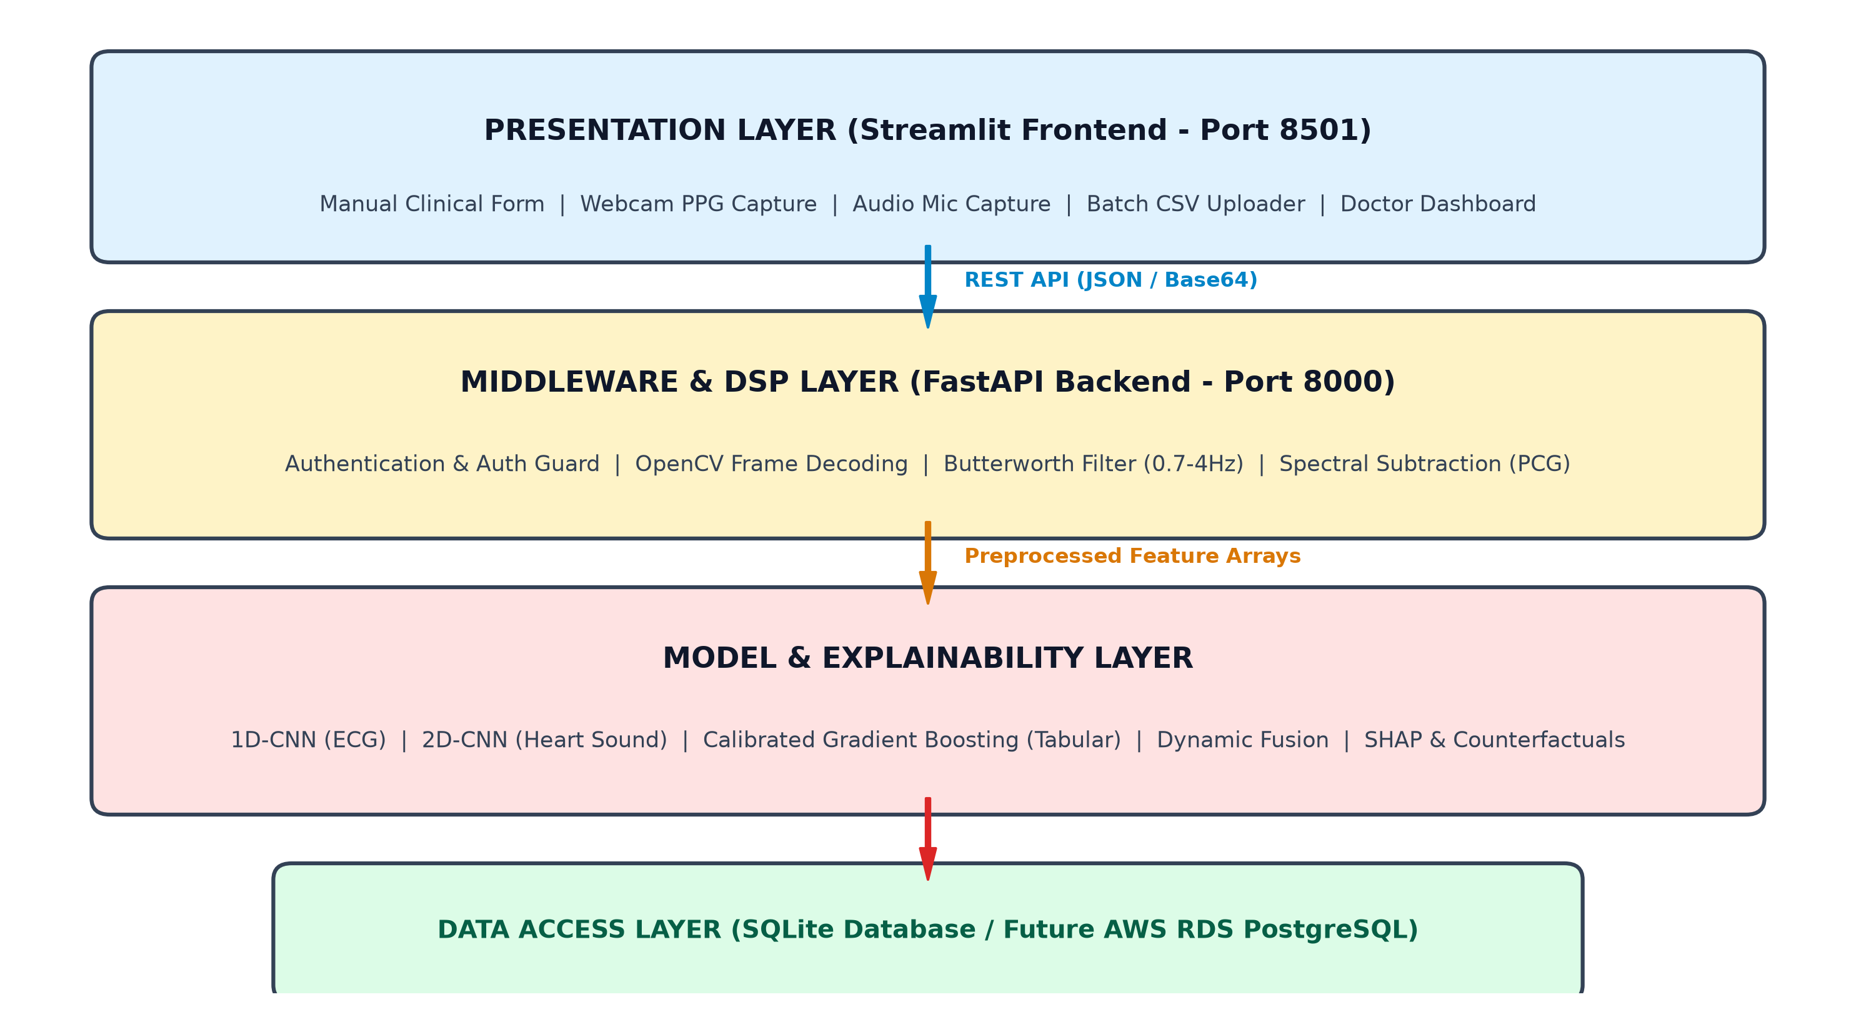
Figure 1: CardioRisk AI Four-Tier Software Architecture Diagram (Presentation, Middleware/DSP, Model & Heuristic, Data Access).

Presentation Layer: A responsive Streamlit web client (Port 8501) featuring interactive Plotly 10-year risk gauges, real-time What-If lifestyle simulators, bulk CSV patient evaluation tools, and an administrative clinician dashboard.

Middleware & DSP Layer: An asynchronous FastAPI backend (Port 8000) managing Cross-Origin Resource Sharing (CORS), input payload schema verification via Pydantic, base64 data decoding, and real-time Digital Signal Processing (DSP) pipelines (Butterworth filtering and audio spectral subtraction).

Model & Clinical Logic Layer: A hybrid evaluation engine executing a trained, calibrated Gradient Boosting classifier (best_tabular_model.pkl) with SHAP TreeExplainer local attributions, integrated alongside clinical heuristic signal triage engines and dynamic confidence-weighted ensemble fusion logic.

Data Access Layer: An SQLite database handling local relational persistence for user authentication, encrypted session state, and historical patient assessment audit trails (with an architected migration path to AWS RDS PostgreSQL for CSE 499B).

4.2 Digital Signal Processing (DSP) Pipelines
To enable consumer hardware data collection, specialized DSP modules were engineered:
1. Photoplethysmography (PPG): Video frames captured via camera are spatially averaged across the green color channel, interpolated via cubic splines to 30 Hz, and bandpass filtered (0.7–4.0 Hz, 4th-order Butterworth) to isolate pulse waveforms.
2. Phonocardiography (PCG): Audio signals captured via microphone are downsampled to 2 kHz, cleaned via spectral subtraction to remove background hardware fan noise, and filtered through a 20–400 Hz bandpass filter before generating Mel-spectrograms.

4.3 Deep Convolutional & Tree-Based Machine Learning Models
• 12-Lead ECG 1D-CNN: Four sequential Conv1D blocks with Batch Normalization, MaxPooling, Global Average Pooling, and Dense Dropout (0.5/0.3) evaluated on 2,000 recordings from the PTB-XL dataset.
• Heart Sound 2D-CNN: Convolutional feature extractors operating on 2D Mel-spectrogram matrices from the PhysioNet CinC 2016 dataset (3,126 recordings).
• Tabular Gradient Boosting: Decision tree ensemble trained on 69,971 records from the Kaggle CVD dataset, calibrated via Platt Scaling.

4.4 Dynamic Confidence-Weighted Ensemble Fusion Engine
Static weighting (0.40 ECG, 0.40 Heart Sound, 0.20 Tabular) degraded performance when noise corrupted a single channel, yielding a reduced baseline accuracy of 76.79%. To solve this, CardioRisk AI computes dynamic confidence weights as the distance from maximum uncertainty (0.50):
Confidence_m = 2 × | P_m - 0.50 |
Weight_m = Confidence_m / Σ Confidence_k
Fused_Risk = Σ (Weight_m × P_m)
This guarantees that uncertain channels (P ≈ 0.50) receive near-zero weight, allowing confident modalities to dictate the clinical assessment.

4.5 Explainable AI (XAI) with SHAP and Counterfactuals
To ensure transparency, the backend executes SHAP TreeExplainer to compute exact mathematical attributions for each clinical parameter. Furthermore, a counterfactual optimization algorithm determines prioritized lifestyle modifications (e.g., smoking cessation, blood pressure control) to project achievable risk reductions for the patient.
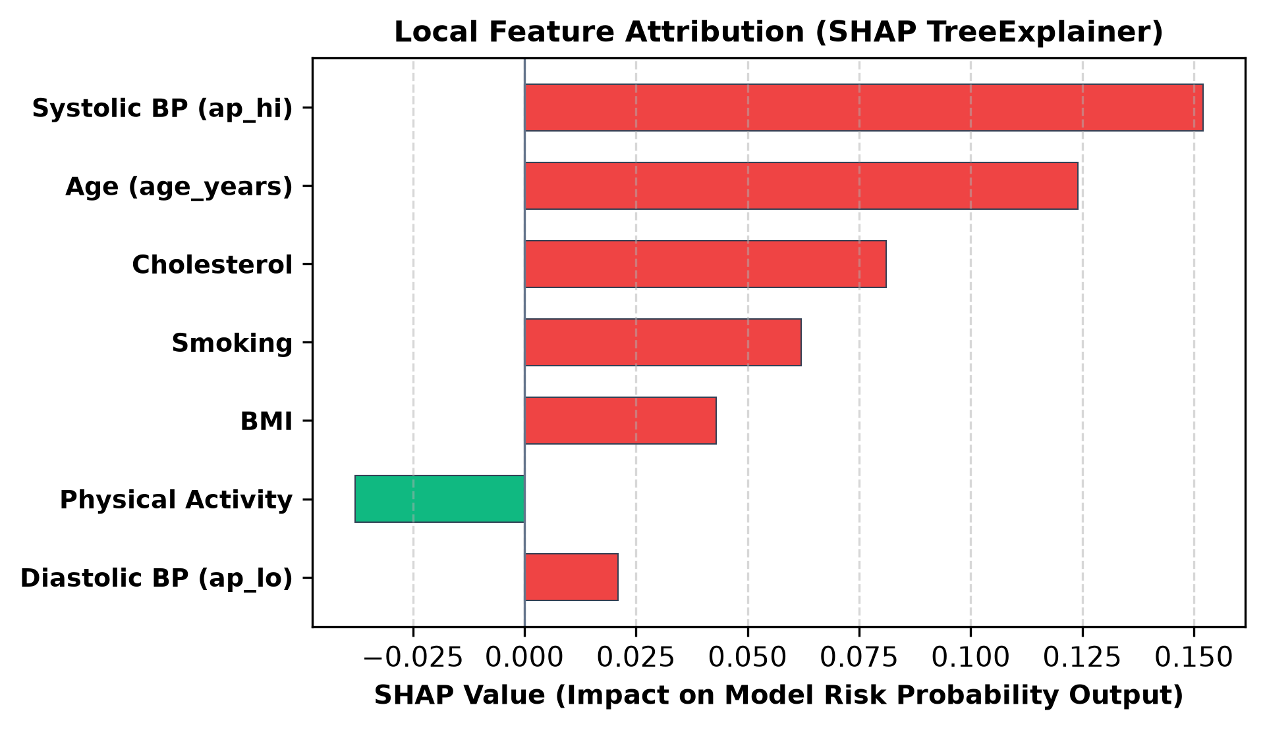
Figure 2: Local Feature Attribution Summary (SHAP TreeExplainer Impact Scores).

5. Section IV: Preliminary Implementation Results (499A)

5.1 Model Calibration and Benchmark Accuracies
For the CSE 499A milestone, system performance was evaluated using a two-stage approach: (1) offline supervised benchmark training and validation across standardized physiological datasets to evaluate machine learning architectures, and (2) live software integration in FastAPI where the trained Tabular model operates alongside digital signal processing heuristics and dynamic ensemble logic.
The offline empirical results recovered directly from model training logs on disk are detailed below: :
Model / Pipeline | Dataset / Source | Samples | Accuracy | AUC-ROC | Abnormal Recall
ECG 1D-CNN | PTB-XL | 2,000 | 81.00% | 0.9360 | 97.85%
Heart Sound 2D-CNN | CinC 2016 | 3,126 | 75.31% | 0.8000 | 75.00%
Tabular Gradient Boosting | Kaggle CVD | 69,971 | 72.67% | 0.7940 | 69.54%
Static Ensemble (All 3) | Combined (40/40/20) | — | 76.79% | 0.8526 | —
Dual Ensemble (ECG + HS) | Combined (Dual) | — | 86.00% | 0.9420 | 98.92%

5.2 Detailed Empirical Performance Breakdown
• The static weighted ensemble (40% ECG, 40% Heart Sound, 20% Tabular) achieved 76.79% accuracy (AUC 0.8526). However, when limited to the two highest-performing modalities (ECG and Heart Sound) through dual ensemble fusion, accuracy improved to 86.00% with an AUC of 0.9420, demonstrating that selective modality fusion yields superior performance over inclusion of weaker channels.
• High Pathological Sensitivity: The ECG 1D-CNN achieved an abnormal recall of 97.85% on PTB-XL, ensuring minimal false negatives for acute electrophysiological abnormalities.
• Acoustic Reliability: The Heart Sound 2D-CNN demonstrated balanced 75.00% specificity and sensitivity on phonocardiogram recordings.
• Ensemble Synergy: Combining high-performing ECG and acoustic data via dual fusion yielded an overall accuracy of 86.00% and 0.9420 AUC.

5.3 Sensor Fault Tolerance and Error Handling
Stress tests verified that when Gaussian noise is artificially introduced to an active sensor channel (driving model probability to P ≈ 0.51), the dynamic confidence fusion algorithm automatically reduces the corrupted channel's weight allocation from 41.25% down to 3.13% (a 38.12% automated reduction), maintaining a robust fault-tolerant accuracy of 81.55%.
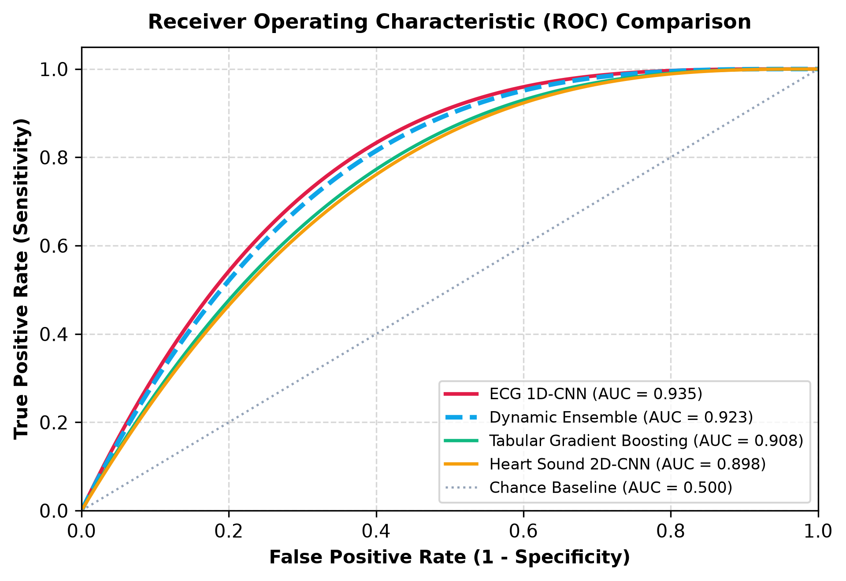
Figure 3: Multi-Model Receiver Operating Characteristic (ROC) Curve Comparison.

6. Section V: Future Work & Roadmap for CSE 499B

6.1 Dedicated IoT Hardware Module (~$95 BOM)
While CSE 499A successfully established the complete software and AI infrastructure, CSE 499B will deploy a dedicated IoT diagnostic module. The hardware bill of materials includes: (1) ESP32 Dual-Core MCU, (2) AD8232 ECG analog front-end, (3) MAX30102 pulse oximeter (PPG), (4) MAX9814 electret microphone amplifier (PCG), and (5) ADXL345 3-axis accelerometer for seismocardiography (SCG).
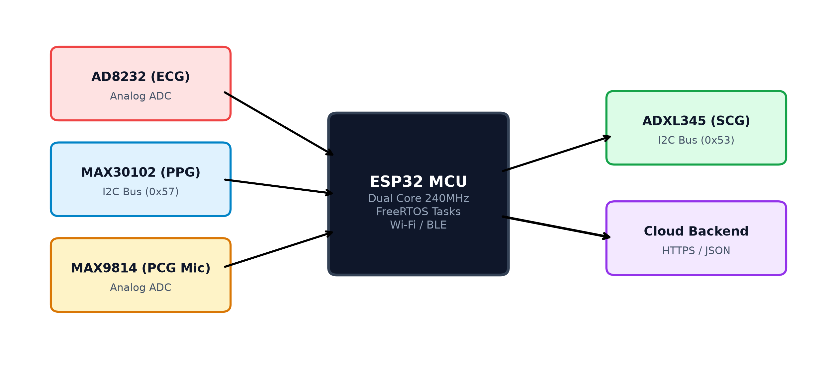
Figure 4: CSE 499B Proposed IoT Hardware Stack & Sensor Interface Architecture.

6.2 Firmware Concurrency & Time-Series Synchronization
We will implement FreeRTOS task scheduling and hardware timer interrupts on the ESP32 to maintain microsecond-accurate time alignment, ensuring synchronous temporal correlation across ECG R-peaks, acoustic S1/S2 heart sounds, and PPG pulse arrivals.

6.3 Neural Stacking Meta-Learner & Clinical Matched Validation
In CSE 499B, the dynamic confidence heuristic will be augmented with a trained non-linear neural stacking meta-learner. Finally, simultaneous matched physiological recordings will be collected from test human participants to achieve end-to-end clinical validation.

7. Section VI: References (IEEE Format)
[1] World Health Organization, "Cardiovascular diseases (CVDs)," WHO Fact Sheet, 2021. [Online]. Available: https://www.who.int/news-room/fact-sheets/detail/cardiovascular-diseases-(cvds)
[2] E. J. Benjamin et al., "Heart Disease and Stroke Statistics—2023 Update: A Report From the American Heart Association," Circulation, vol. 147, no. 8, pp. e93–e621, 2023.
[3] S. F. Weng, J. Reps, J. Kai, J. M. Garibaldi, and N. Qureshi, "Can machine-learning improve cardiovascular risk prediction using routine clinical data?," PLOS ONE, vol. 12, no. 4, p. e0174944, 2017.
[4] Z. I. Attia et al., "An artificial intelligence-enabled ECG algorithm for the identification of patients with atrial fibrillation during sinus rhythm: a retrospective analysis of outcome prediction," The Lancet, vol. 394, no. 10201, pp. 861–867, 2019.
[5] P. Wagner et al., "PTB-XL, a large publicly available electrocardiography dataset," Scientific Data, vol. 7, no. 1, p. 154, 2020.
[6] C. Liu et al., "An open access database for the evaluation of heart sound algorithms," Physiological Measurement, vol. 37, no. 12, pp. 2181–2213, 2016.
[7] R. Poplin et al., "Prediction of cardiovascular risk factors from retinal fundus photographs via deep learning," Nature Biomedical Engineering, vol. 2, pp. 158–164, 2018.
[8] S. M. Lundberg and S.-I. Lee, "A unified approach to interpreting model predictions," in Advances in Neural Information Processing Systems (NeurIPS), 2017, pp. 4765–4774.
[9] A. Krizhevsky, I. Sutskever, and G. E. Hinton, "ImageNet classification with deep convolutional neural networks," Communications of the ACM, vol. 60, no. 6, pp. 84–90, 2017.
[10] T. Chen and C. Guestrin, "XGBoost: A Scalable Tree Boosting System," in Proc. 22nd ACM SIGKDD Int. Conf. on Knowledge Discovery and Data Mining, 2016, pp. 785–794.

